DEMO LINK: <https://youtu.be/95YWnFOXdmc>

[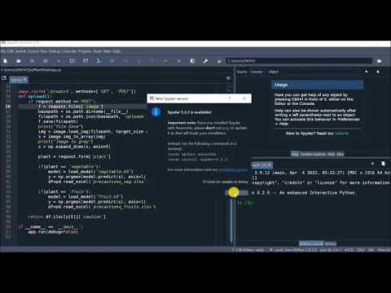](https://www.youtube.com/embed/95YWnFOXdmc?feature=oembed)